a)

It is called as ‘Twelve-Pulse Rectifier’. This topology is used for improving dc output over single phase rectifier. Output has less harmonics, the frequency of output is 6 times of input. In addition, there are two transformers, one of them Y-Delta, other one is Y-Y. Y-Delta is required to create a 30 degree phase shift. So, six phase is created by using only 2 transformers and three phase sources.

Dc output of the 12- pulse rectifier is the sum of 2 rectifying unit, one is 30 degree shifted.



Equation 1

For diode rectifier, firing angle is zero. Equation 1 shows that average output voltage is bigger than full bridge diode rectifier.

Kinds of this topology are used in the high voltage DC application. Output level is increasing and ripple is decreasing without using capacitance and inductance filter. For the HV DC rectifying, filtering to output requires more cost components like capacitor and inductor.

The multi phase converters like 12 pulse branch single-way and bridge rectifier. Some converters are 3 phase single way, 6 phase single phase, 6 pulse bridge. This rectifier can be compared in respect to average output level, output ripple frequency and output ripple. Number of phase increases the output voltage and decreases the ripple and ripple frequency. In addition, bridge rectifers are better than single way rectifiers with respect to output voltage and ripple value if the phase numbers are equal.

b)

# Simulation Setup and results for 12-Pulse Rectifier

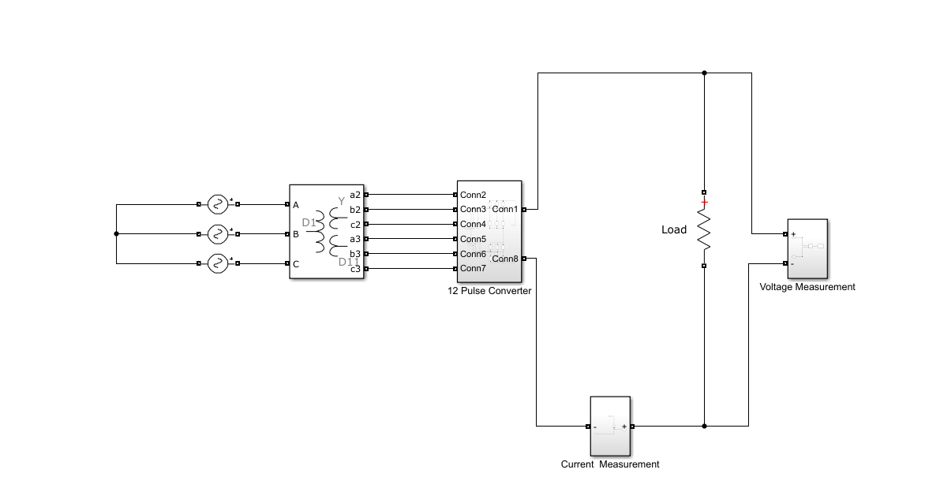

Figure 1

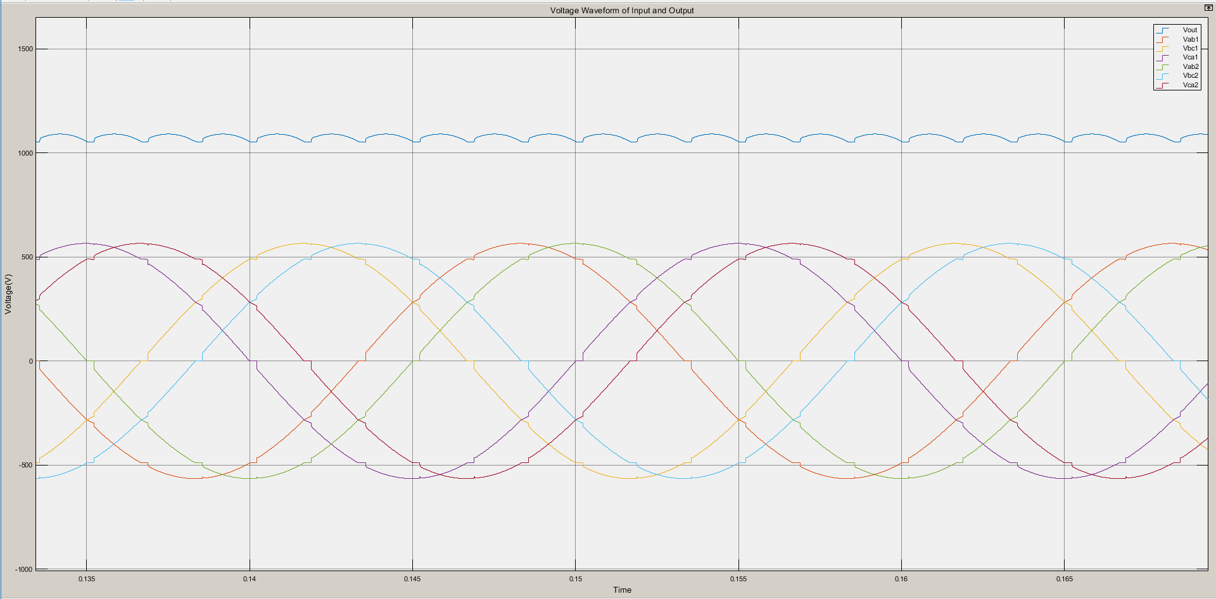

Figure 2

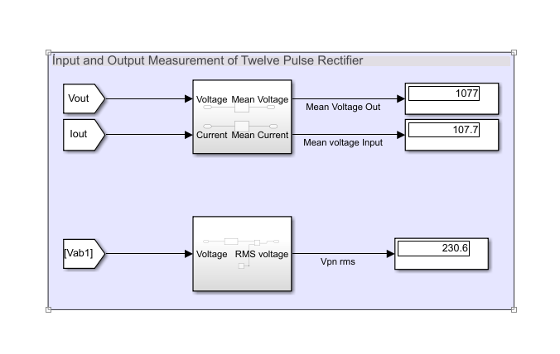

Figure 3

# Simulation Setup and results for Full Bridge Rectifier

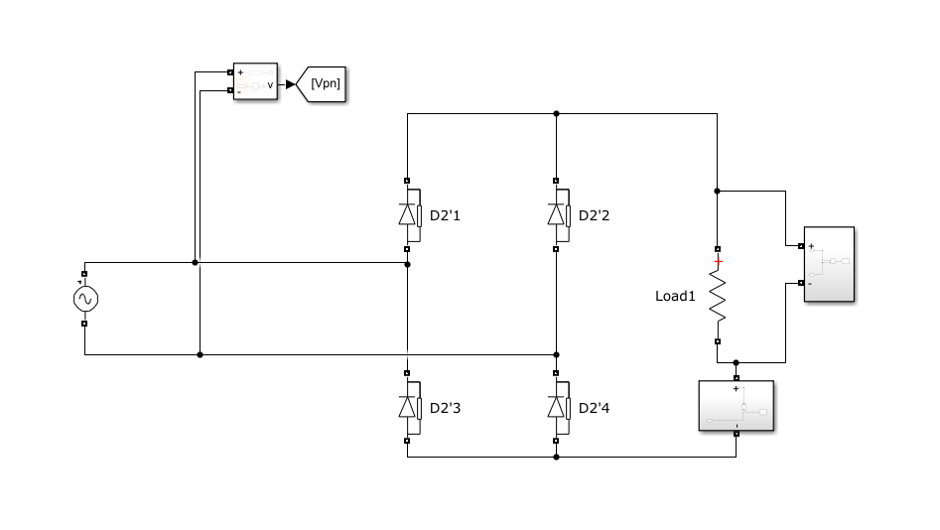

Figure 4

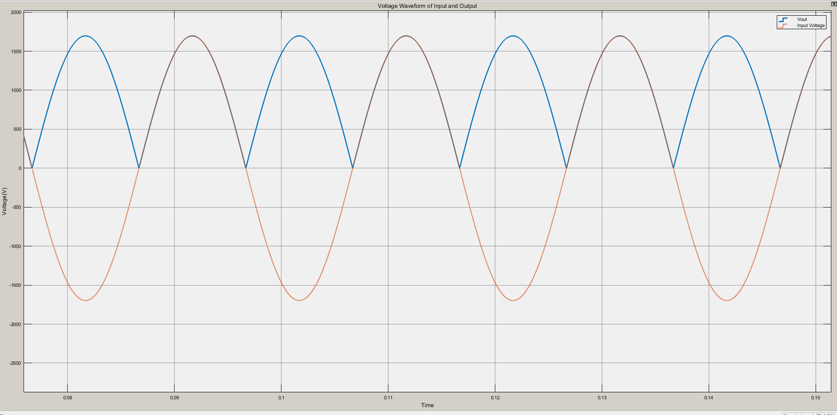

Figure 5

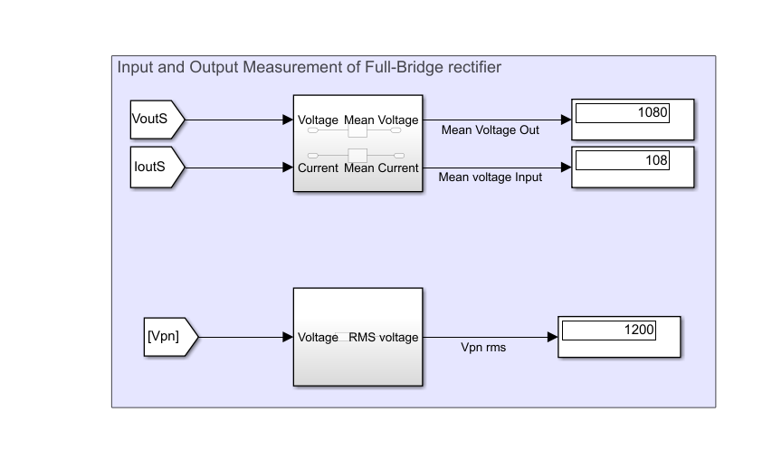

Figure 6

# Comparasion